Name: NGO TUNG CHUONG
ID: s225586848

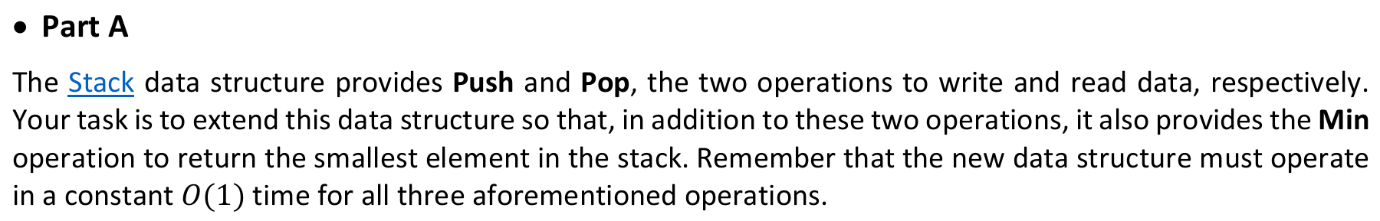
Function Push(x) {
MainStack.Push(x);

If (MinStack.IsEmpty() OR x <= MinStack.Peek())
MinStack.Push x;
else {
MinStack.Push(MinStack.Peek());
}
}
Pop() – remain the same
Min() {
Peek();
}

Function Pop() {
MinStack.Pop(); // help two stack sync
Return MainStack.Pop();
}

Function Min() {
Return MinStack.Peek();
}

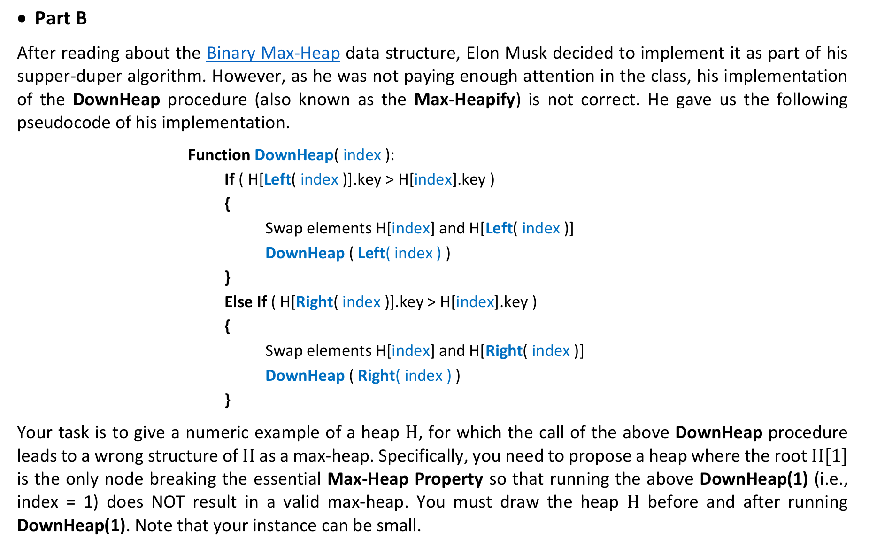
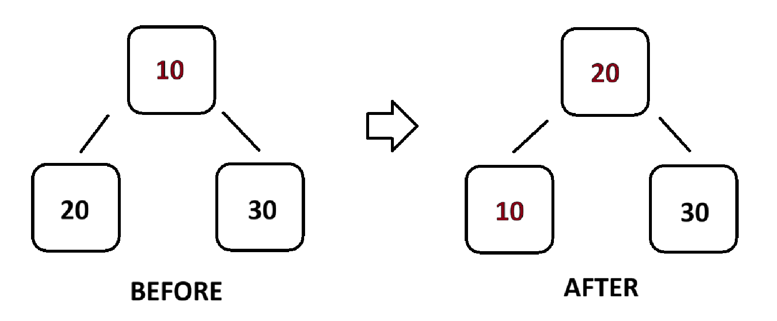

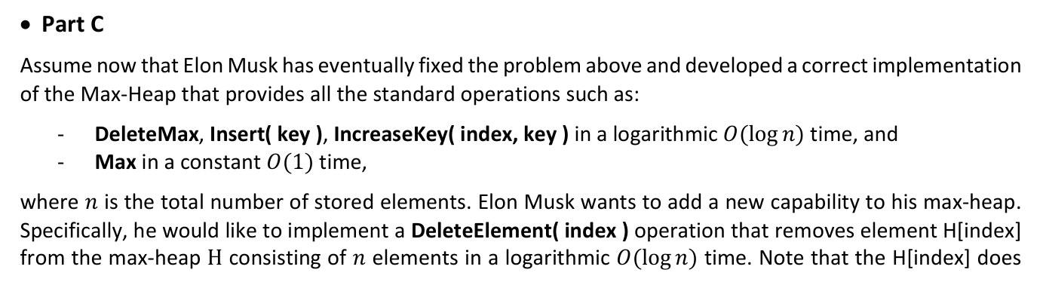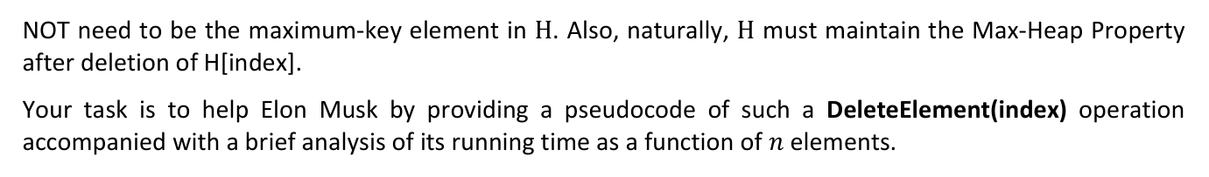
Pseudocode:
Function DeleteElement(index) {
if (index < 1 OR index > H.size) return ERROR; // base case
IncreaseKey(index, int.MaxValue); // we make the element at index
// become largest number in Heap Tree
DeleteMax();
}

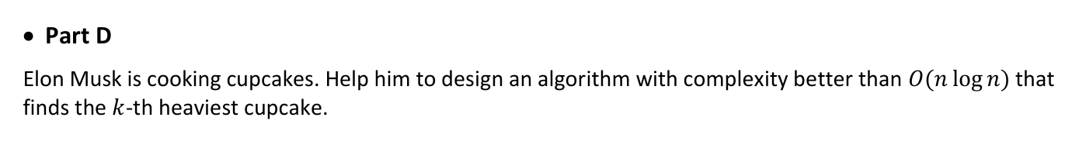
I will apply the “Partition” logic of Selection Algorithm of QuickSort. Instead of sorting both sides of a pivot, it only recurses into the partition that contains the kth largest element. With the average time complexity of O(n). Which better than O(nlogn).
Where I take the inspiration from: Selection Algorithms - GeeksforGeeks

